Room 3 Question 1
Gallstone Ileus
Stem: A 76-year-old demented woman presents to the emergency department from her nursing facility with 4 days of intermittent abdominal pain, confusion, food intolerance, emesis and diminished urinary output.
Past medical history includes Alzheimer’s dementia, COPD, CAD, HTN, cholelithiasis, HLD.
Past surgical history includes total abdominal hysterectomy.
Examination: HR 110bpm, BP 106/43mmHg, 92% sats on room air, 36.6C. Abdomen is distended and tympanic however soft, with generalized tenderness without involuntary guarding or signs of peritonitis.

Pertinent labs: WBC of 12.4, LA 2.4, NA 130, Chloride 92. LFTs, lipase and amylase are within normal limits.

What studies would you order?

- Abdominal xray
- CT scan
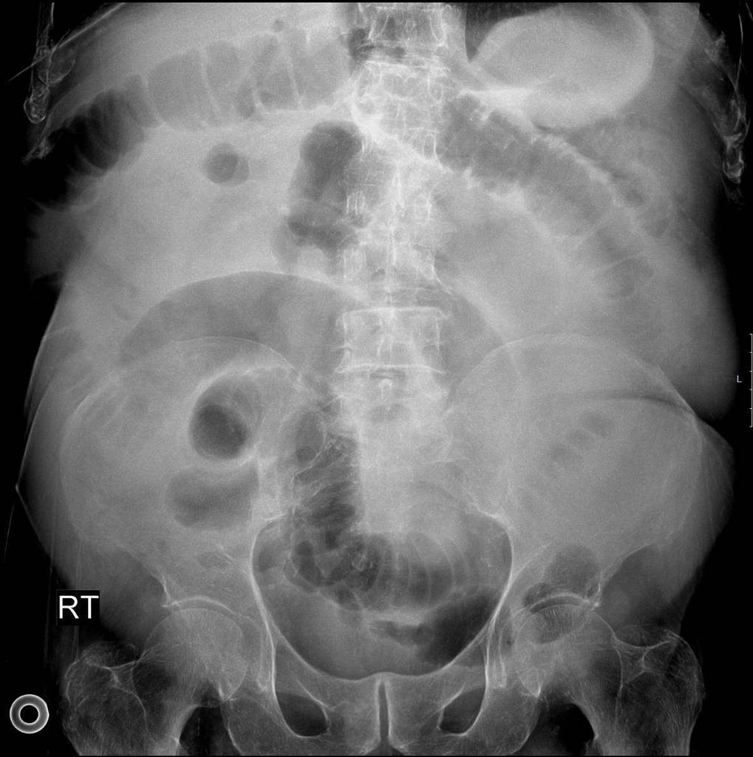

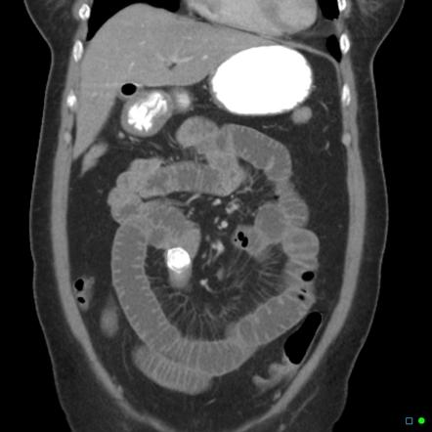

What is your differential diagnosis?
- Small bowel obstruction
- Gallstone ileus
- Mesenteric ischemia
- Intestinal perforation
- Malignancy

What would you like to do now?
- NGT decompression
- IV access
- Resuscitation.

Recognition of gallstone ileus on imaging
- OR for ex-lap
  - Inspect/palpate entire midgut
  - Longitudinal enterotomy, stone extraction and closure in H-M fashion

How do you mange cholecystoenteric fistula?
leave it alone in old, frail and sick people

Scenario 1: Same patient, however, you are unable to milk the stone out proximally.
Perform a segmental small bowel resection.
Scenario 2: Same patient successfully treated with enterotomy with stone retrieval and primary closure of the small bowel. In the coming days becomes increasingly tachycardic, febrile, and hypotensive.

What is you diagnosis? How would you manage
Enteric leak
- IVF resuscitation.
- Empiric abx.
- If stable CT
- Versus Immediate return to OR

Scenario3: Gallstones ileus identified in a 60-year-old farmer with history of HTN and HLD, otherwise physically active and relatively healthy.
What would you do with the gallbladder and cholecystoenteric fistula in this setting?

- Explores gallbladder and identifies whether there are residual stones
- If patient is stable and can undergo long procedure would be acceptable to perform cholecystectomy and closure of cholecystoenteric fistula at time of surgery, otherwise perform as staged procedure.
- At time of cholecystectomy, performs cholangiogram to ensure CBD exploration does not need to be performed.

Describe how to repair the duodenum?
Debride edges if needed, assess posterior wall and ampulla, primary repair transversely to avoid stricture. Protection of repair: buttress with omental fat/falciform, serosal flap. JP drain.

Cholecystectomy Complications
Stem: Patient is a 65-year-old man who presents to the emergency department 3 days after laparoscopic cholecystectomy for acute, calculous cholecystitis. He has been having worsening epigastric and RUQ abdominal pain, PO intolerance, chills, fevers, jaundice, darkened urine.
He is otherwise without significant past medical or surgical history.
Exam: HR 114bpm, BP 94/37; 94% on RA, 38.8C, Ill appearing, lethargic, jaundice, scleral icterus Mildly distended, TTP in the RUQ and epigastrium.
Pertinent labs: WBC 16.4k; Tbili 4.3; AST 143; ALT157; ALK Phos 312; Creatinine 1.73 (normal 0.90)

What’s one initial study would you like to order now?
RUQ US –dilated intra and extrahepatic bile ducts with CBD measuring 1.1cm, mild RUQ fluid, and distal common bile duct stone.

How are you going to manage this patient.
- Sepsis workup.
- Resuscitation / hydration/ antibiotics.
- ERCP : You are not credentialed to do it and your GI colleague is on vacation.
- PTC: Your IR colleagues are not available
- Urgent CBD exploration:
  - Open CBD Exploration.
  - Kocherize the duodenum, palpation of the common bile duct to assess location/mobility of the stone, exposure of anterior CBD
  - Place sutures at the 10 and 2 positions and make an anterior vertical ductotomy.
  - Flush duct with small diameter red rubber and pass a biliary Fogarty catheter proximally and distally until all stones are removed.
  - Choledochoscope can be used with wire basket to retrieve challenging stones.
  - Close ductotomy over a 14 fr T-tube
  - Perform completion cholangiogram.
  - Leave JP drain.

Scenario 2: Same patient arrives, RUQ US notes intra and extra hepatic ductal dilation, mild fluid, no stone is appreciated. You are now in a tertiary center with all images and expertise available.
- ERCP or MRCP or advanced imaging to delineate etiology → 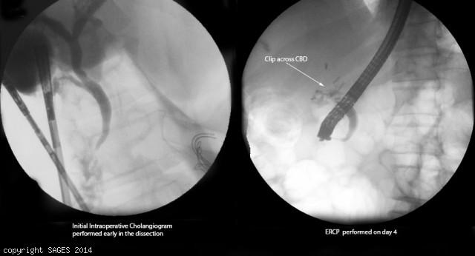
Concern for clip across CBD
- Antibiotics
- IR consultation for PTC.
You take the patient to the OR for repair, how do you repair the following?
- Injury < 50% circumference, not caused by cautery - Repair over T tube.
- Transection < 1 cm in size and away from bifurcation - End to end anastomosis.
- More severe injury, or close to the bifurcation: Hepaticojejunostomy -- Describe.
Scenario 3: Same patient however with AST/ALT and Alk phos within normal limits, Tbili slightly elevated to 2.4. RUQ US shows concern for large fluid collection in the RUQ.
1. HIDA: Shows biliary leak.
2. ERCP obtained → cystic duct stump leak confirmed → Sphincterotomy and Stent
3. IR for drainage of RUQ fluid collection if symptoms do not resolve, persistent leakage or septic.

